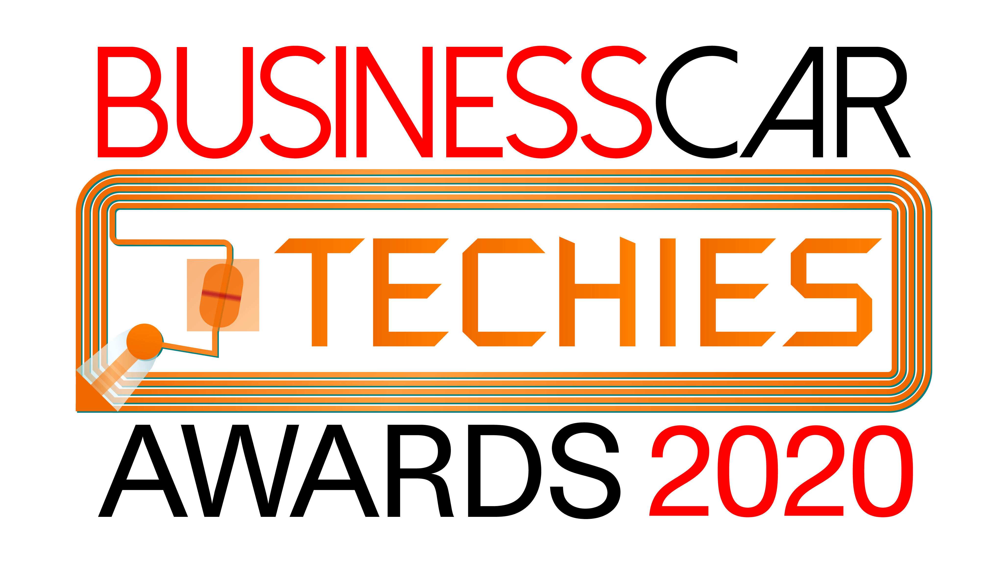

Innovation Award

Name:

Email:

Company name:

Job title:

Telephone:

Company entering award:

Award accepter and job title:

Tell us about a digital product or service introduced during the last 12 months that is new, or brings a new perspective to an aspect of running a vehicle fleet that offers tangible benefits. Please list some of your key fleet clients or partners to demonstrate evidence of serving the corporate sector.

